How to configure the ssh keys in Git and GitHub

Okay so how do I configure the ssh keys?

Well, I too was wondering the same till a friend of mine helped me, and thus that motivated me to write this really quick guide.

First:

Head to configurations

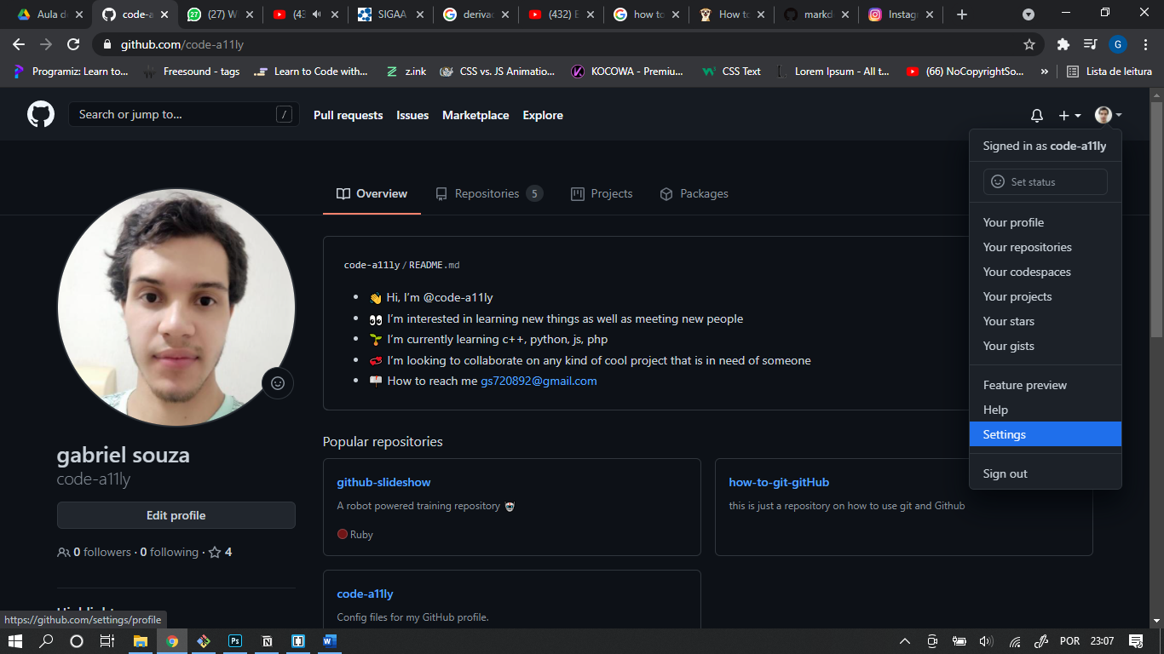

SSH and GPS keys

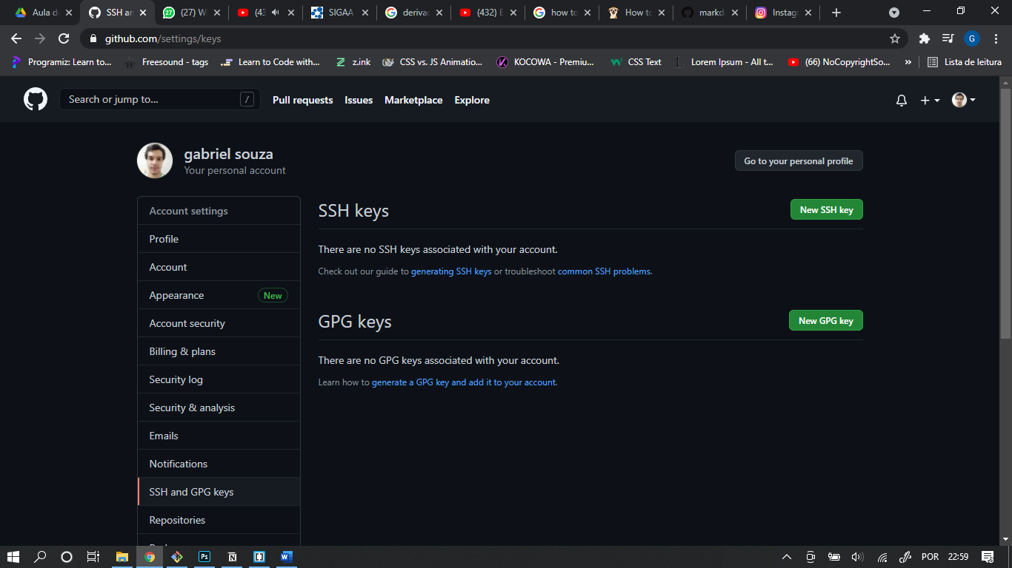

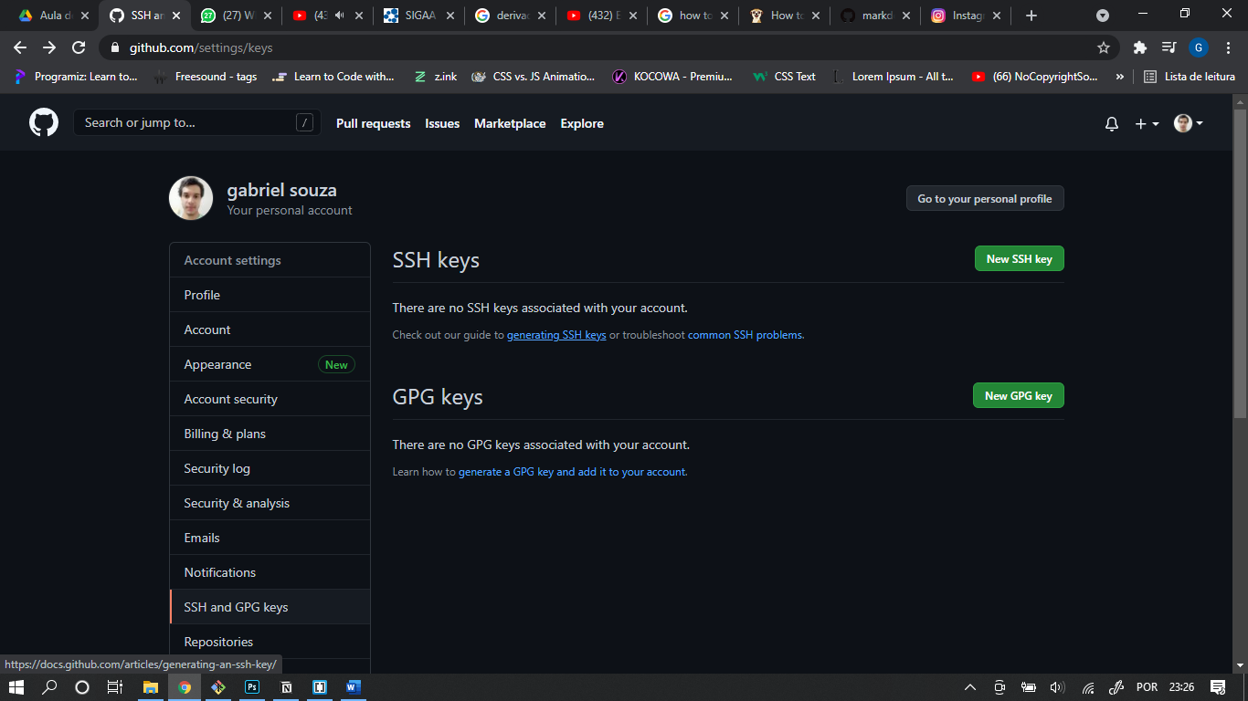

New SSH key

